LO4
4.1. Identifying Gaps and Omissions in the Testing Process
The following gaps were identified during the testing process:
There was no rigorous testing on any of the early endpoints such as
- Pathfinding Tests:
  - Limited tests on edge cases for the delivery pathfinding algorithm.
  - Lack of tests for dynamic updates or alternative routes.
Ordervalidation tests:
there Was provided 600 orders to test, all of which passed, but there is no guarantee that these orders explore every single edge case
Stress tests:
Didn’t test the system under a massive load of tests which it could need to handle at peak times
4.2. Identifying Target Coverage/Performance Levels for Different Testing Procedures
- Pathfinding Performance:
  - Target runtime: Less than 60 second for calculating the delivery path under standard conditions.
- Order Validation:
  - Target result: Pass all provided functional tests for the validateOrder method without errors.
- Test Coverage:
  - Default target: Achieve at least 80% code coverage during testing, ensuring that critical functions are thoroughly tested.
4.3. Comparison of Testing Results with Target Levels
- Pathfinding Results:
  - Achieved runtime of less than 1 second for most delivery paths, except from one restaurant, where the calculation took approximately 2 seconds. These results are exceptionally below the target which shows the pathfinding algorithm is highly efficient and acceptable for this system.
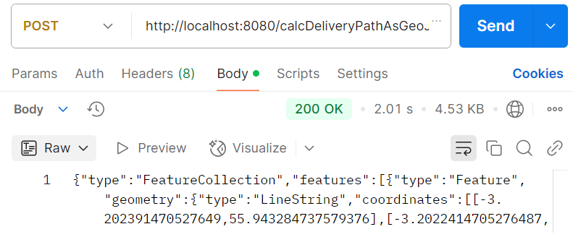
This is a picture of the runtime of calcdeliverypathasgeojson on the furthest away restaurant
- Order Validation Results:
  - All functional tests for order validation were passed successfully.
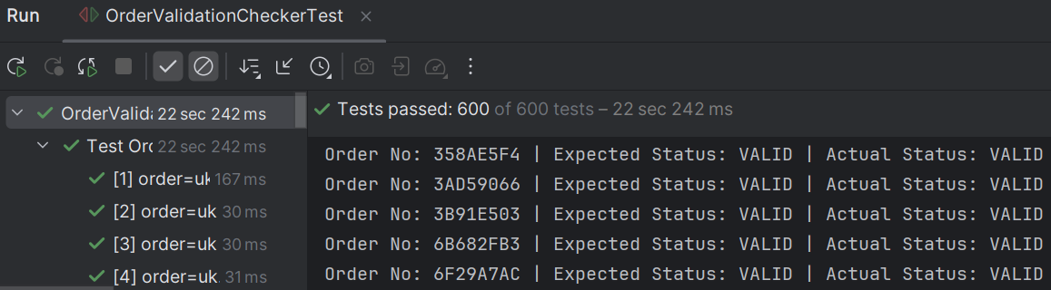
- Test Coverage:
  - (add the actual % and a picture of what the coverage was)
4.4. Necessary Steps to Achieve Target Levels
To achieve and exceed the target levels, the following steps were completed:
- Pathfinding Optimisation:
  - The pathfinding algorithm used a modified A* with heuristic scaling for faster, accurate paths, limiting iterations and pre-processing regions to avoid no-fly zones.
  - A heuristic guided the algorithm using scaled Euclidean distance to prioritize efficient, realistic paths.
- Order Validation:
  - Strict input validation was introduced to ensure all order data adheres to the expected format before processing.
  - test cases specifically targeting invalid or incomplete orders ensured robustness.
- Test Coverage Analysis:
  - Test coverage was monitored using intellij.
  - Test coverage was increased by focussing on edge cases in pathfinding and order validation logic.
  - Another way it was increased was by adding automated tests for all of the endpoints, initially only validateOrder was tested automatically.

